Rainbow Color Digital Tube DS3231 Clock instructions

Please read the entire production process carefully and then do it better.

Let me first talk about the issues that need attention before soldering.

- The soldering temperature is below 320℃, the soldering iron temperature can not be too high, otherwise it may damage the LED.
2. Soldering LED soldering iron must be grounded and it is best to wear an electrostatic bracelet for grounding soldering. The soldering speed needs to be fast.

OK, let's get started. This is a relatively simple SMD soldering kit. It is more soldered LEDs. It requires patience to solder. It is basically no difficulty.

First of all, we solder the LED, the LED corner is corresponding to the LED package with black spots in that direction, 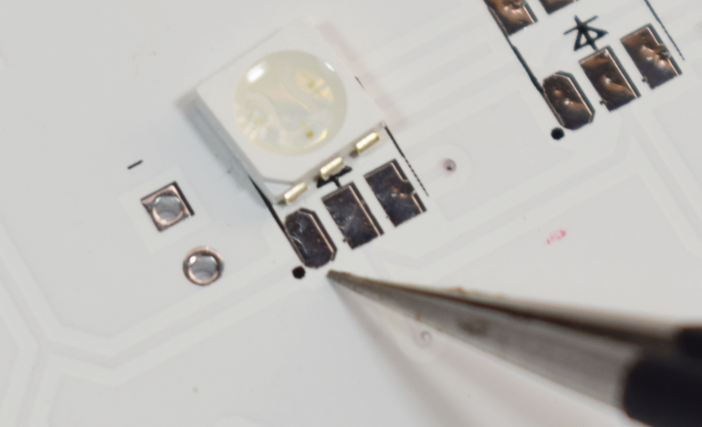

First add solder to a pad, then heat the solder to fix a pin of the LED. 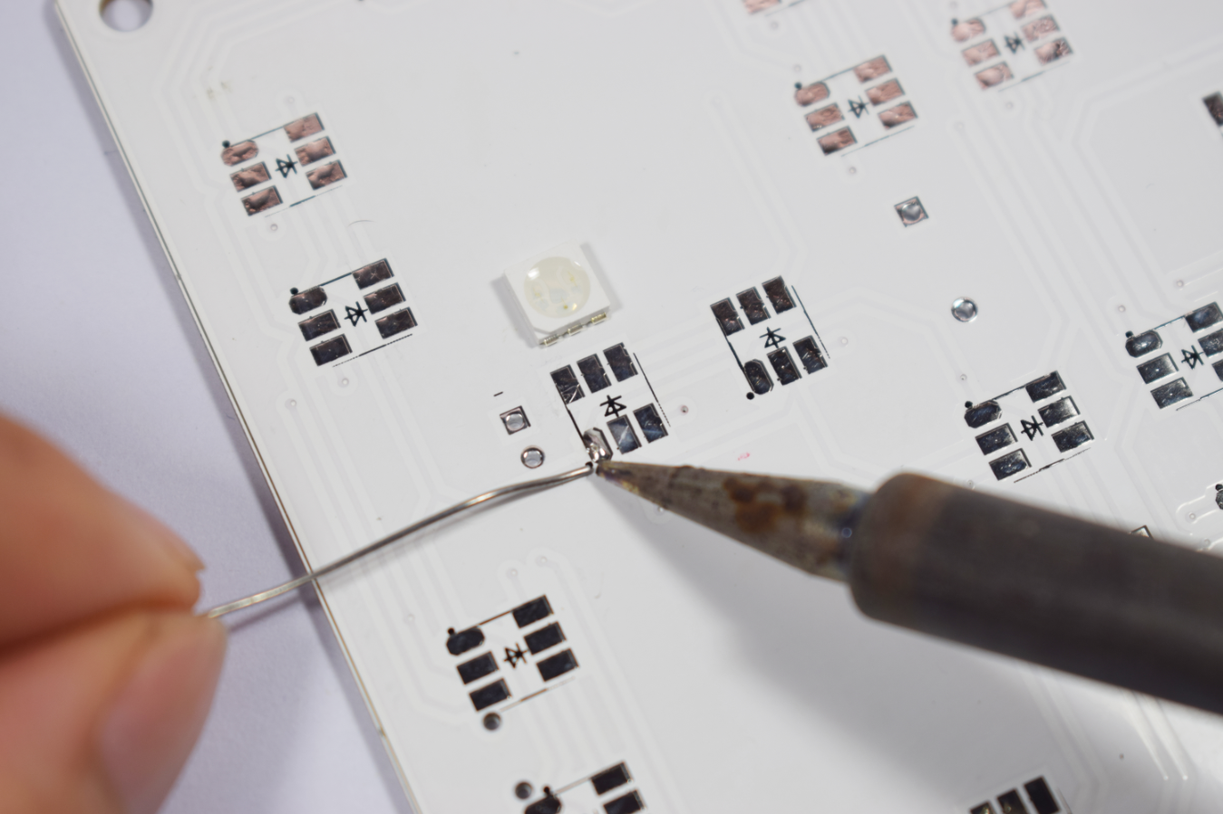
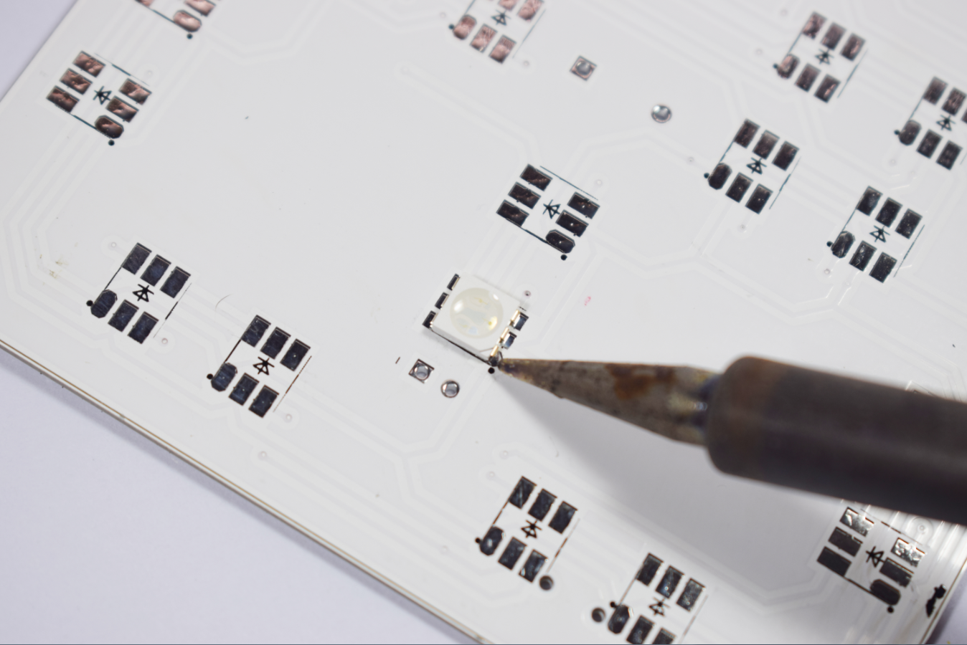

Then solder the remaining pins, all the LEDs are the same soldering method 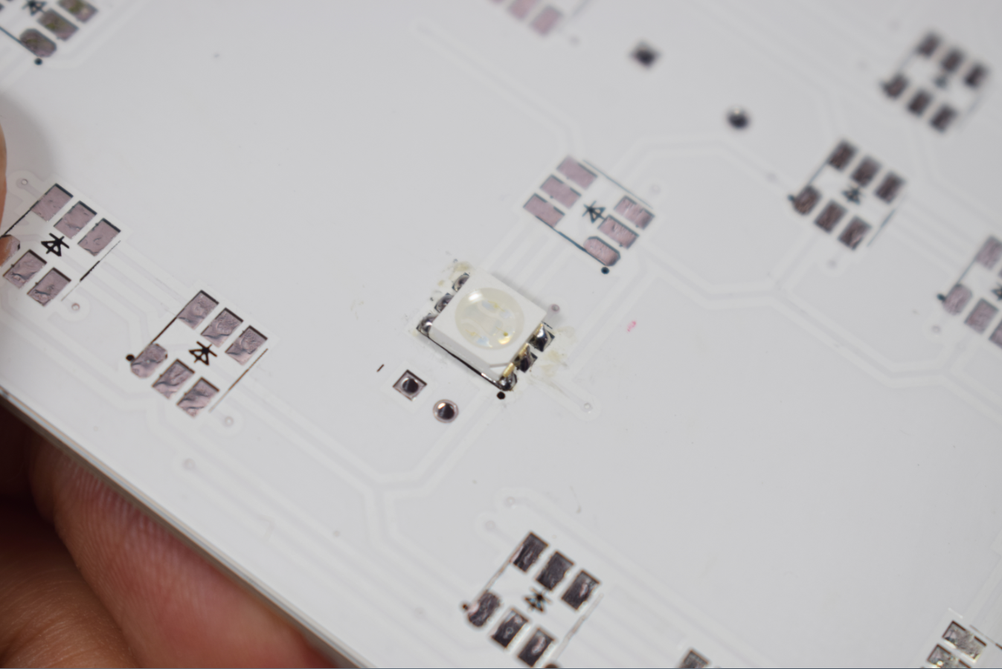

After all the LEDs are soldered 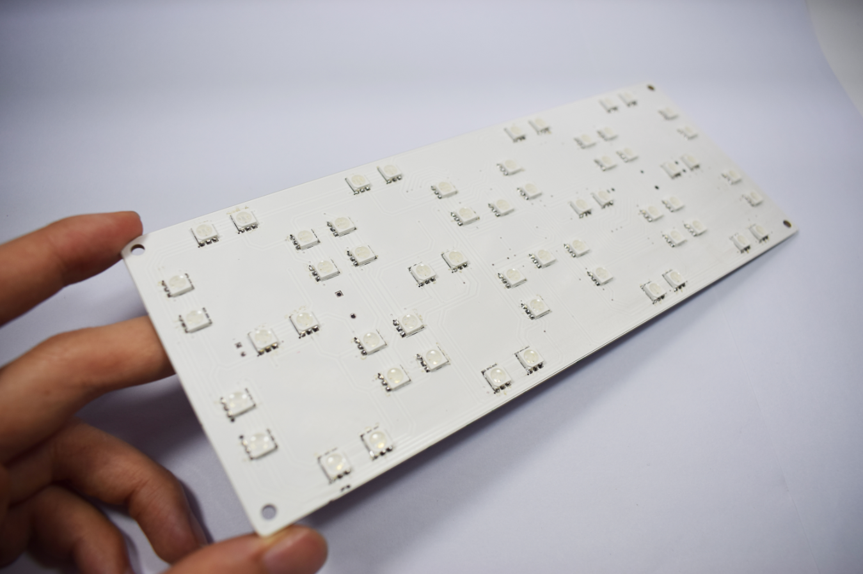

Next, solder the mini usb socket, first cut off the three pins in the middle of the mini USB socket, leaving only the two of the following figures. 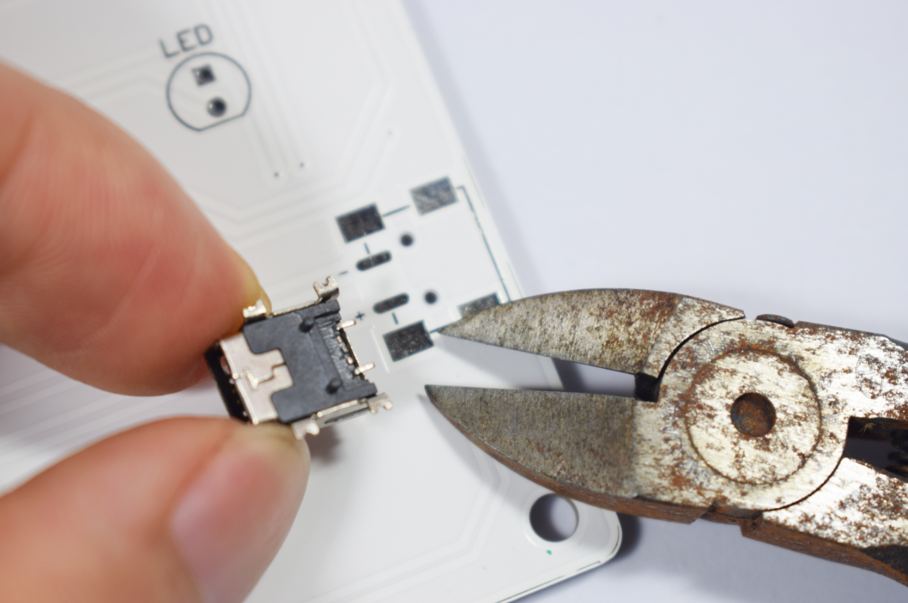

mini usb socket is welded as shown below 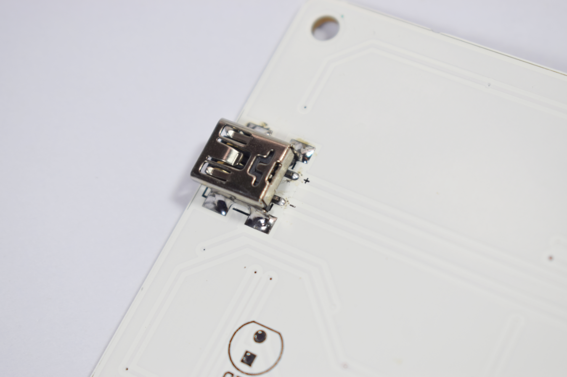

Next, solder the in-line LED, the LED long foot is inserted into the square pad for soldering, and the LED is soldered as shown below. 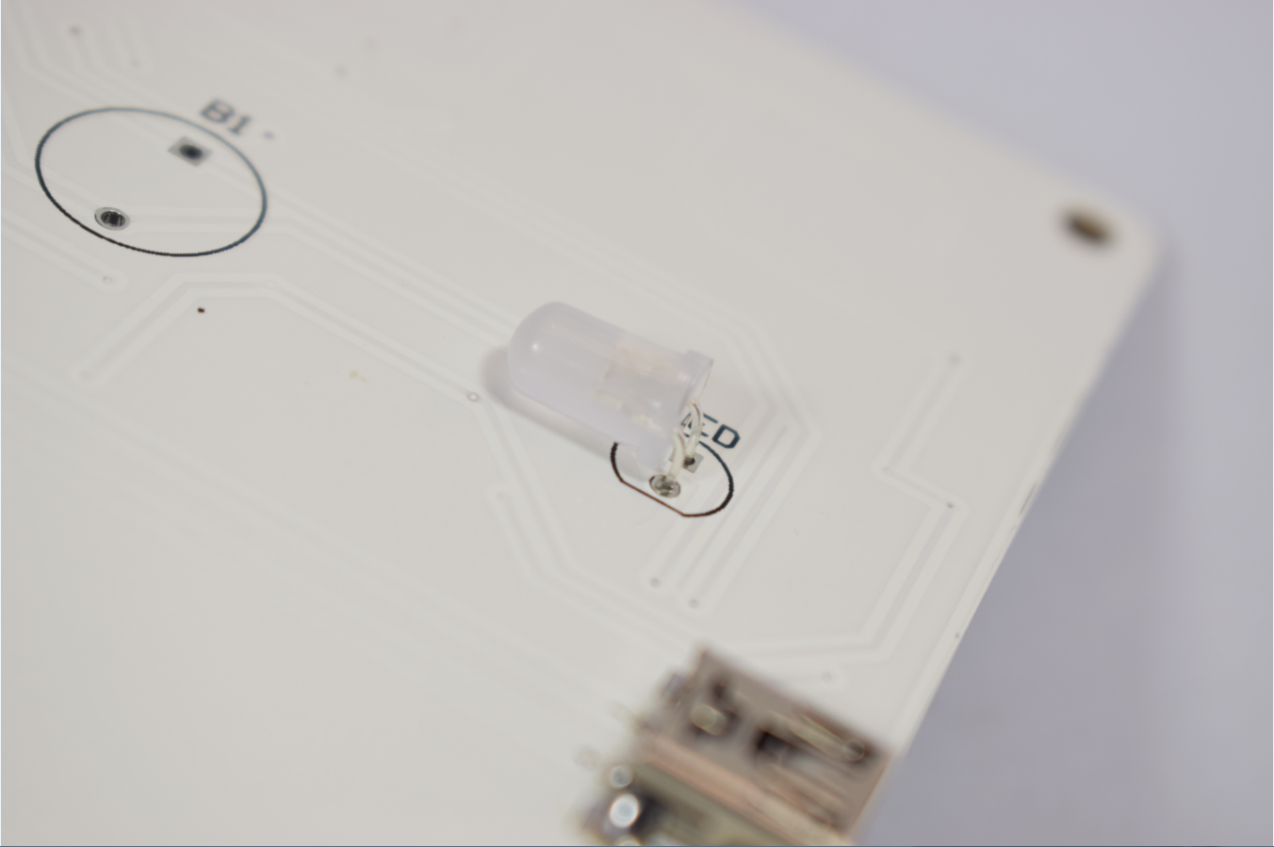

Below are solder IC and chip capacitor resistors
R1-R2:1M(105)
R3:2K(201)
R4-R8:10K(103)
C1:220uF capacitor
C2: 100nF(104)
C3:10uFcapacitor
C4-C5:100nf(104)
U1: MCU (please pay attention to the direction, the IC pit corresponds to the direction of the package black dot)
U2：AMS1117
U3：DS3231 chip
B1:Passive buzzer (buzzer positive pole corresponding to square pad)
LR1:Photoresistance
BT1:CR1220 Battery Holder
MIC:microphone

After soldering, it is as follows 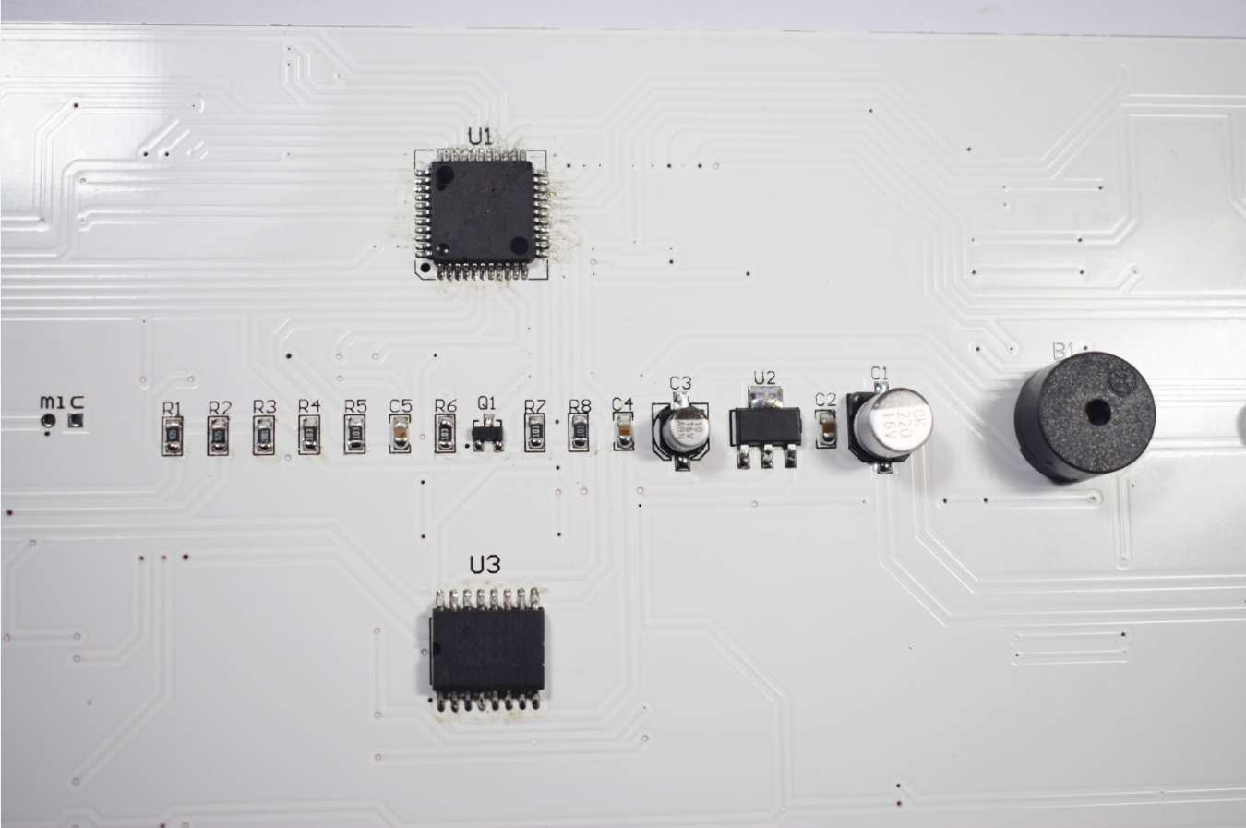

The back of the microphone has three leads connected to the negative pole, and the negative pole corresponds to the circular pad, as shown below 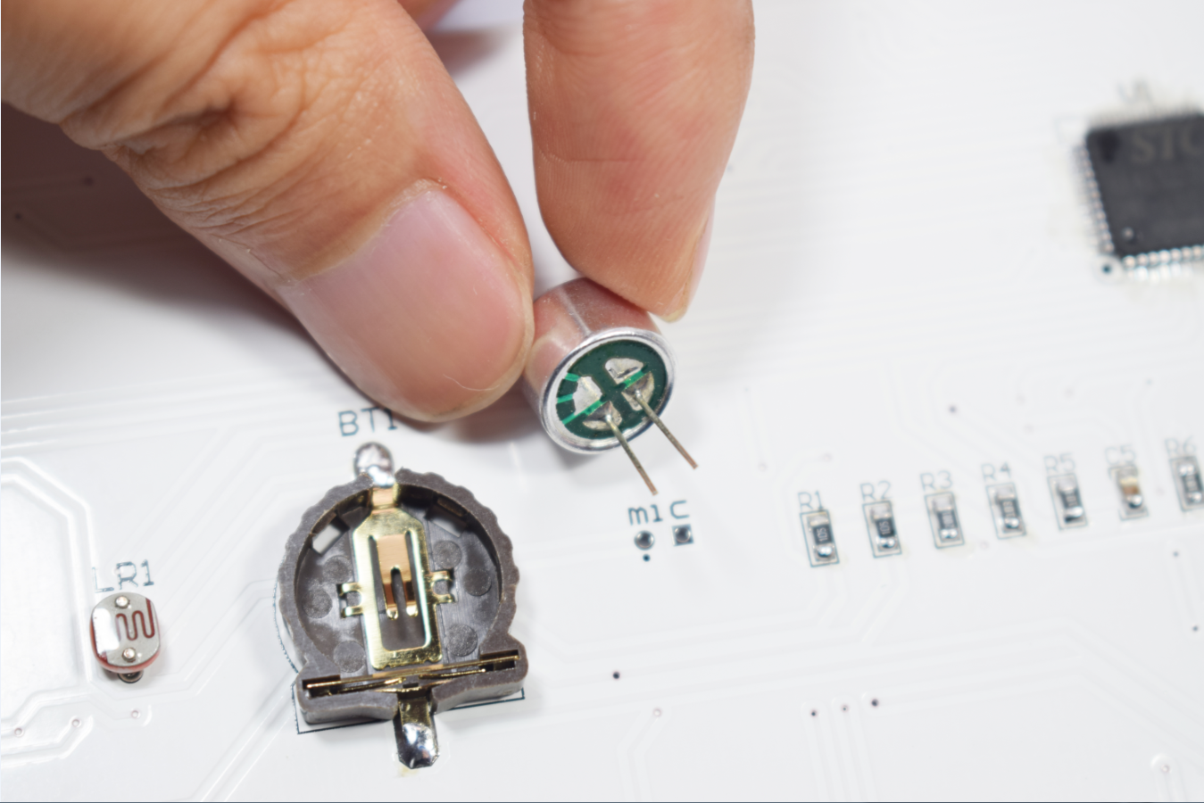

After all the devices are soldered, please plug in the usb power supply and test whether all LEDs are normal. If the illumination is not correct, please check if the LED has a short circuit or a weak soldering.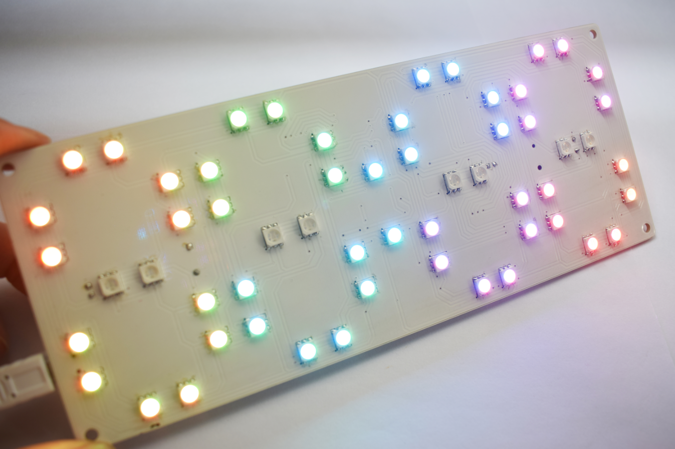

After the test is normal, install the shell below, first tear open the black acrylic protective film, put the sticker on the flat patch acrylic, please try to stick it flat, as shown below 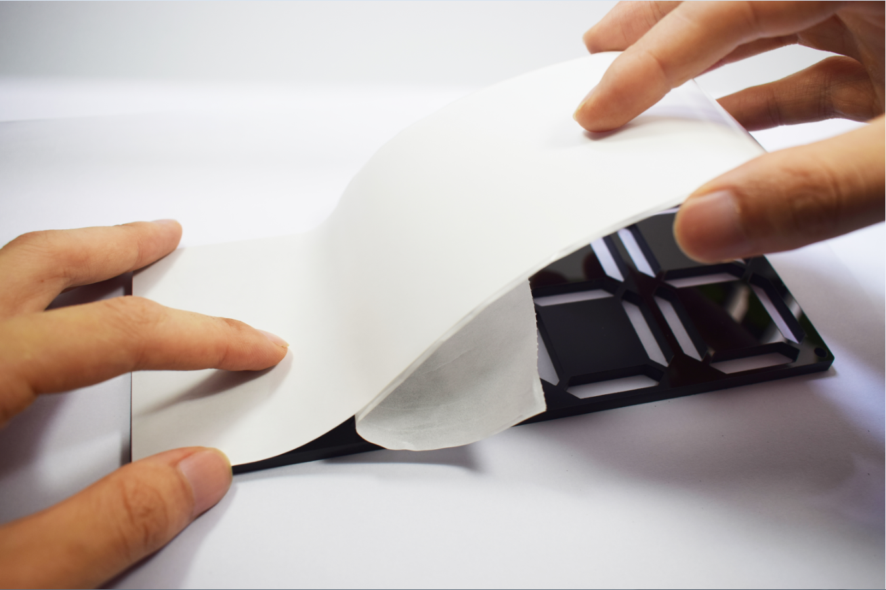

Then use a pair of tweezers to poke in the screw hole position, as shown below 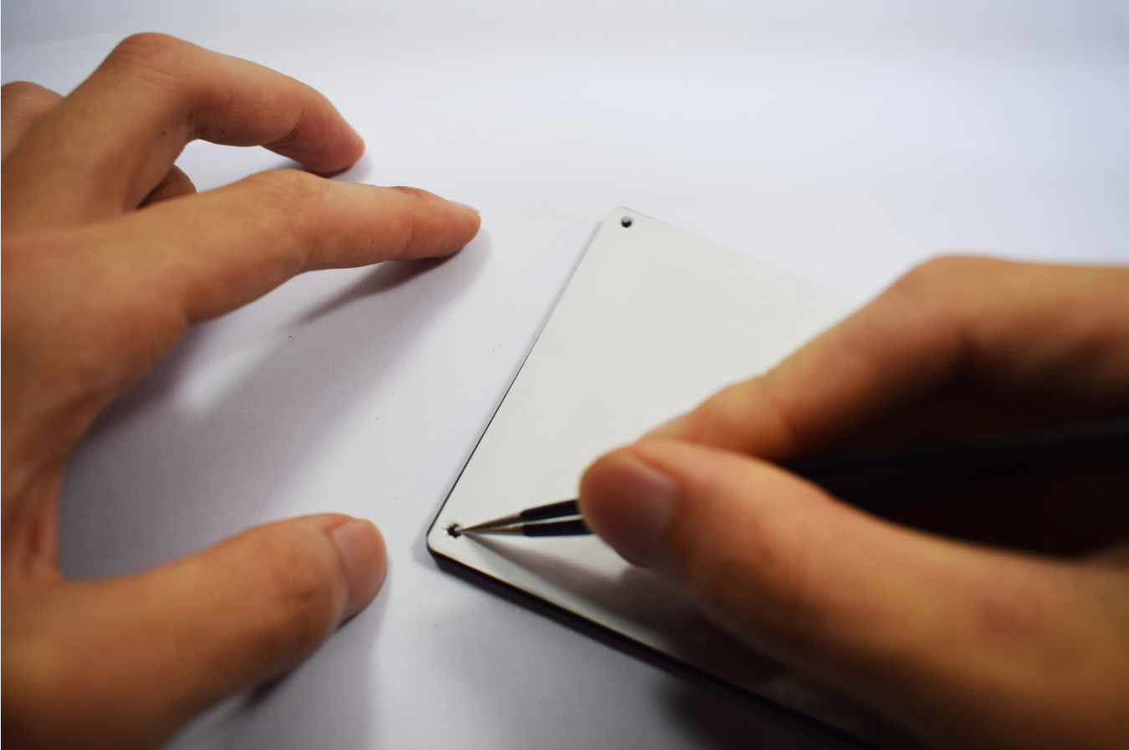

Finally install transparent acrylic panel
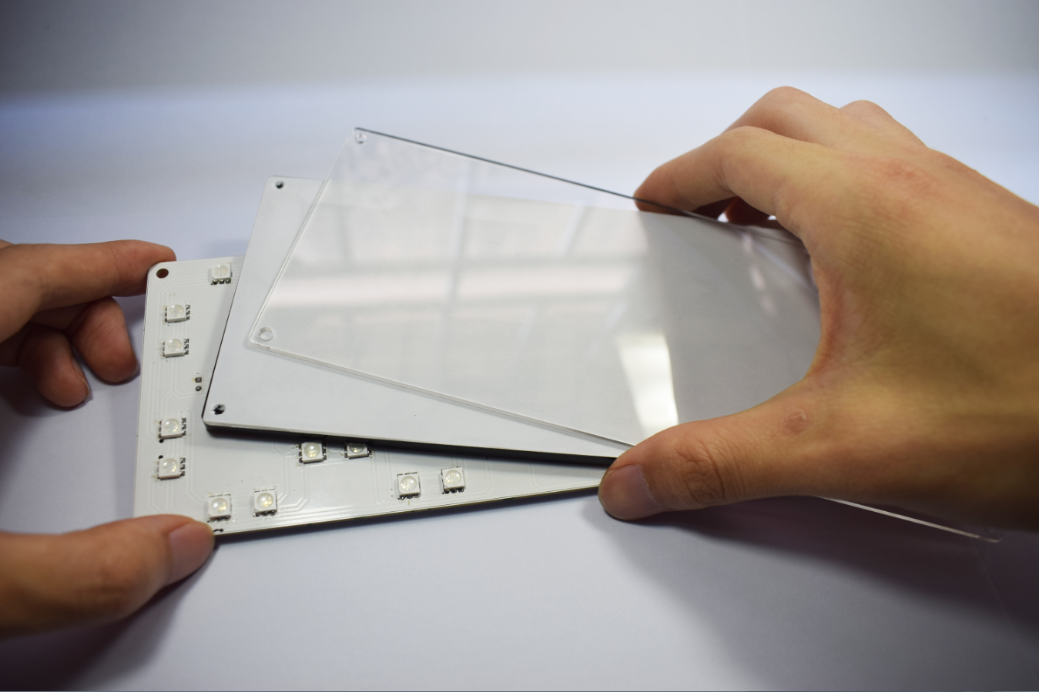

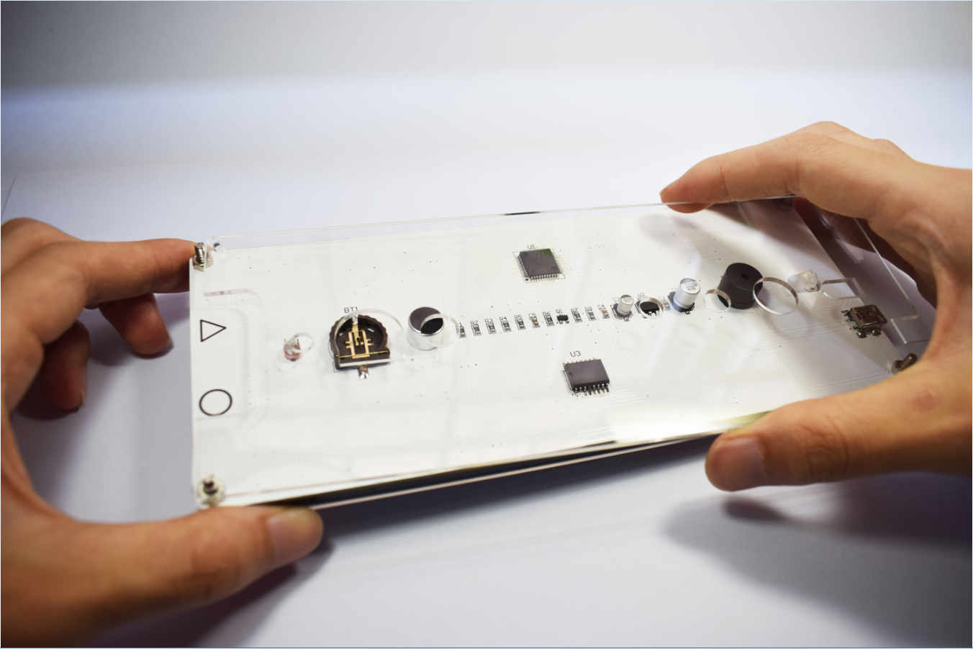

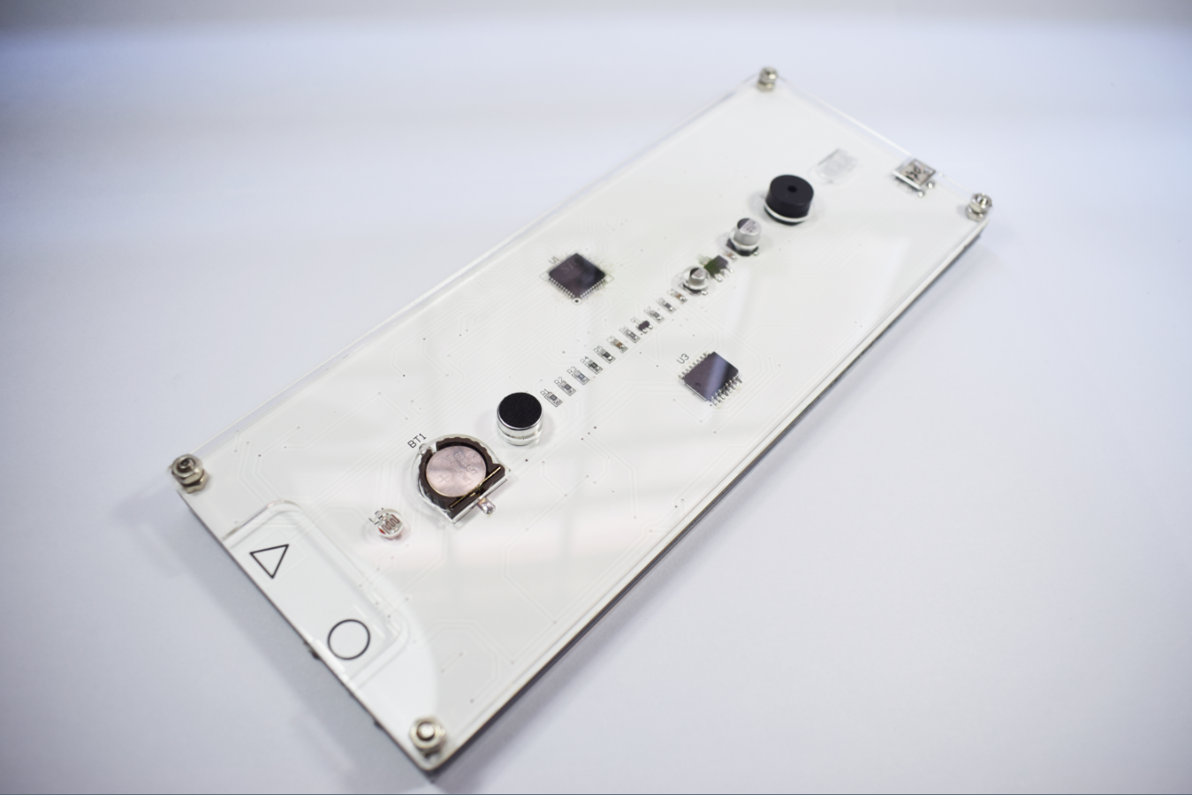

It is recommended to use a high quality 5V charger to supply power, not to use a poor charger to supply power, poor charger is prone to interference
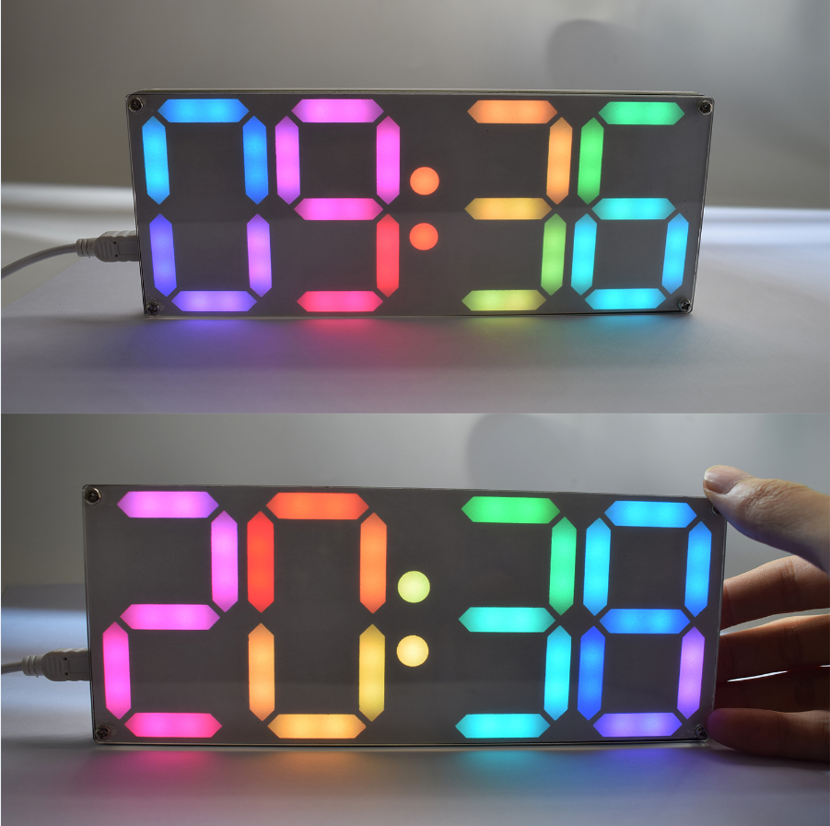

Function setting description:
1. Press the setting (circular symbol) + switch touch key (triangle symbol) to enter or exit the menu at the same time;
2. Short touch switch button (triangle symbol) can switch time setting (Time) - date setting (Date) - alarm setting (Alarm) - format setting (Format) - switching animation effect setting (Display) - setting information switching duration (Speed) - Midpoint Colon Bounce Effect Setting (Midpoint) - Color Gradient Effect (Color) - Color Gradient Speed (Color Speed) - Voice Switch Setting (Voice) - Brightness Setting(Brightness) - Time Digital Variation Effect Setting (Move) - Countdown setting (Count). Short press the set key (circular symbol) to enter the setting, and then modify the parameter value by switching the key (triangle symbol).

Parameter Settings:
1. Time: The switch key (triangle symbol key) modifies the flashing parameter value, and sets the key (circular symbol key) to determine the modification;
2. Date: The order of modification is: year-month-day;
3. Alarm: ON - turn on the alarm and enter the alarm time setting; OFF - turn off the alarm
4. Format settings (Format):
Hour (hour format): 24h-24 time mode; 12h-12 time mode.
Date (date format): M-DD: month-day mode; DD-M: day-month mode.
Temp (temperature format): C-degree Celsius; F-Fahrenheit;
5. Switching mode (Display):
0-display time only;
1-rotation switching;
2-up and down switching;
3-down switching;
4-switching from left to right;
5-flashing switching;
6-direct switching;
6. Information switching speed setting (Speed):
5_-5 seconds to switch information;
10_-10 seconds to switch information;
30_-30 seconds to switch information;
60_-60 seconds to switch information;
2M-2 minutes to switch information;
10M-10 minutes to switch information;
7. Colon jump effect setting (Midpoint):
0-normally bright mode;
1-breathing mode;
2-second lighting mode;
3-up and down lighting mode;
8. Color effect settings (Color):
0 - enter custom settings color(See Custom color);
1 - all gradient mode;
2 - different digital color gradient mode;
3 - rainbow color gradient mode;
4 - left and right aurora color gradient mode;
5 - up and down aurora Color gradient mode
Custom color: switch key (triangle symbol key) modify the color value of the flashing number (a total of 13 colors), set the key (circular symbol key) to determine the modified color and enter the next digital color;
9. Color gradient speed setting (Color Speed): 1-5 speed optional;
10. Voice control settings (Voice): ON - turn on the voice mode; OFF - turn off the voice mode
11. Brightness level setting (Brightness):
1-4 levels of brightness;
A- automatically adjust the brightness according to the environment;
12. Time digital change effect (Move):
0 - direct change;
1 - rotation + flash mode;
2 - up and down mode;
3 up and down + left and right flash mode;
4 - segment by flash mode;
5 - random mode;
6 - flash +Up and down mode
13. Countdown setting (Count): Enter the minutes and seconds, press the setting button (circle) to start the countdown, the countdown ends the buzzer, and any touch button to exit the countdown;

