Power Button For RPi SKU: EP-0077

Content
- 1 Power Button For RPi
  - 1.1 Description
  - 1.2 Features
  - 1.3 Dimension
  - 1.4 Package Includes
  - 1.5 Mechanical Drawing
  - 1.6 Parameters
  - 1.7 How to wire it up
  - 1.8 How to set it up

Power Button For RPi
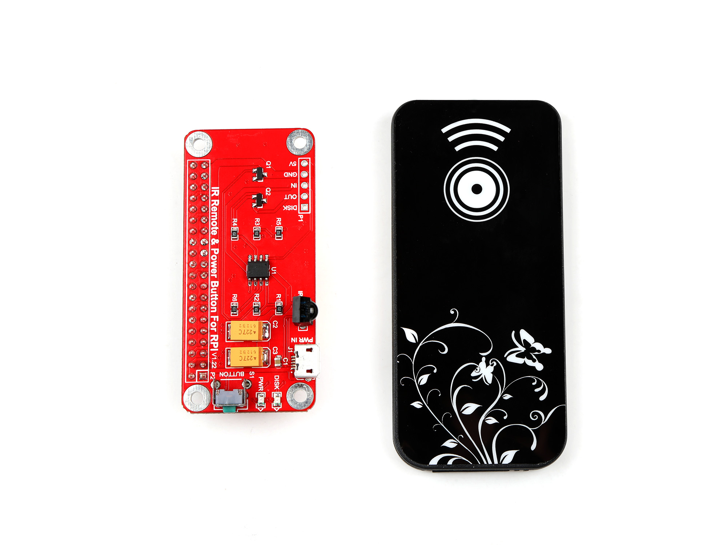
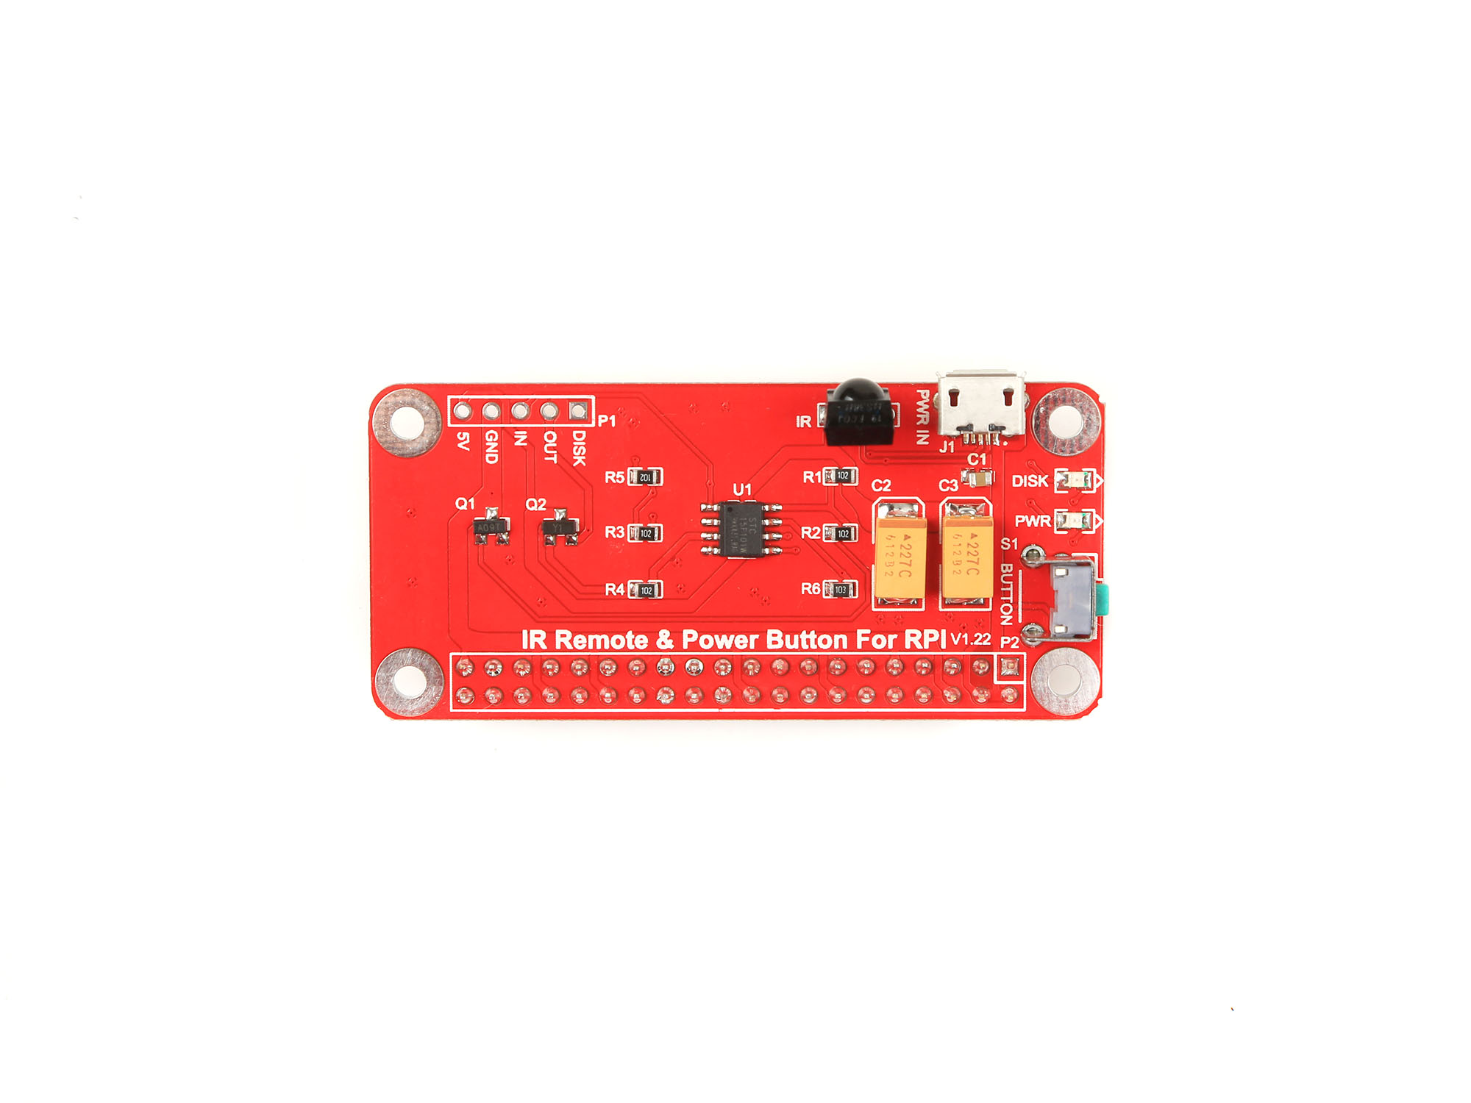
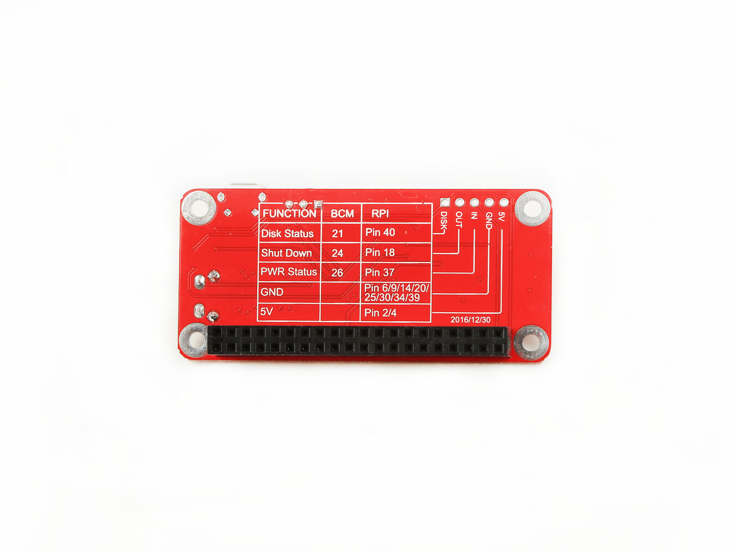

Description
As everyone at some point will recognize the Raspberry Pi doesn't include any kind of shutdown button.
So the only way to power it off is by unplugging it from the power supply.
To make sure you get no corruption of your data files on the SD card you should shutdown the Raspberry before powering it off.
So the whole procedure can be a bit annoying especially if you want to use the Raspberry as some kind of embedded PC .
e.g. a media server or an internet radio.

Features
Power Button provides a small circuit that includes the features:
- Sending a shutdown signal to the Raspberry if the Shutdown Button is pressed
- Powering off the Raspberry after save shutdown
- Powering on the Raspberry after the Button is pressed again
- LED light indicating the current state: On / Shutdown / Off
- Easy to setup

Dimension
Parameter | Value
Dimension | 65mm x 30 mm x 20mm
Weight | 22.72g

Package Includes
- Power Button For RPi Module x1
- IR Remote controller ( without battery) x1

Mechanical Drawing
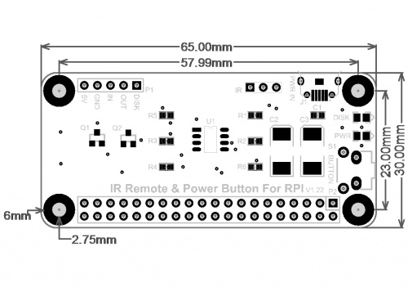

Parameters
There is a chart which can show you the function of the GPIO Pin definition of this board:
Function | BCM | RPi
Disk Status | 21 | Pin 40
Shut Down | 24 | Pin 18
PWR Status | 26 | Pin 37
GND | N/A | Pin 6/9/14/20/25/30/34/39
5V | 5V | Pin 2/4
NOTE: Please make sure that your Raspberry Pi have 5V/2.5A power supply with this module!!!

How to wire it up
Do NOT connect your power supply to Raspberry Pi, Please connect it to Power Button directly.
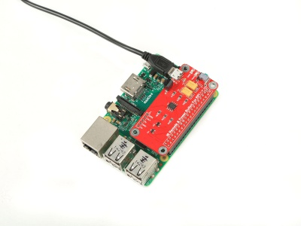
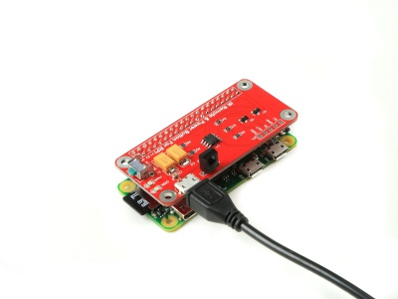

How to set it up
- 1. Remove your TF card and connect it to your PC or laptop with TF card adapter.
- 2. Modify /boot/config.txt file as following:
device_tree=bcm2710-rpi-3-b.dtb
dtoverlay=power-off,gpiopin=26
dtoverlay=pi3-act-led,gpio=21
- 3. Download shell script:
$sudo apt-get install -y wiringPi
$cd ~
$git clone #https://github.com/yoyojacky/powerbuttom.git
$cd ~/powerbuttom
$sudo mv ~/powerbuttom/gpioshutdown /etc/init.d/
$sudo chmod +x /etc/init.d/gpioshutdown
$sudo vim.tiny /etc/rc.local
Add this two lines before exit 0
gpio mode 25 out
gpio write 25 1
- 4. Reboot your Raspberry Pi and plug power button on your RPi, press the button to test.
Have fun.

