Fashion MP3 Smart Walking Stick Manual
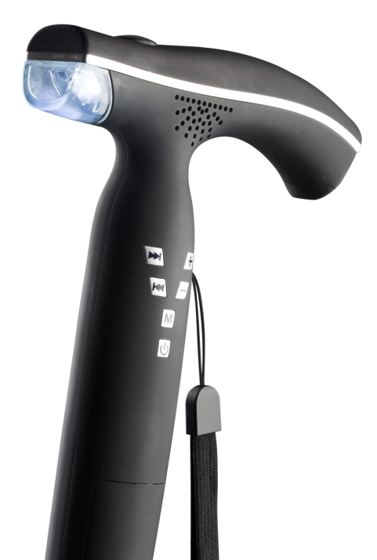
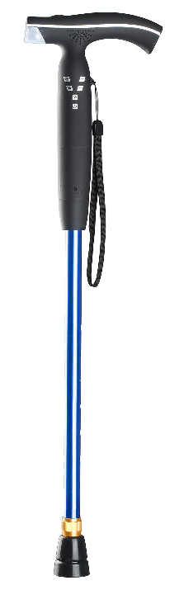
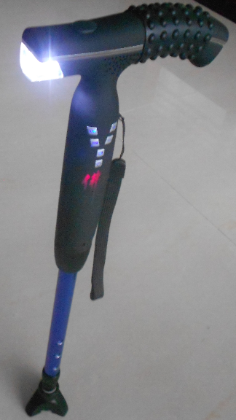

MP3 Smart Walking stick functions and features:
1, Patented products, the handle in accordance with ergonomic design, use very comfortable.
It is the daily necessities, gifts, collectibles.
2, MP3 function: insert TF card, free to enjoy the favorite Beijing Opera, classical oldies, ballad, etc
3, LED light: Night lighting, preventing elderly stumble wrestling,30000 hours service life.
4, FM radio: auto search and store, listening to the news and weather.
5, Alarm + flashing: emergency, Press the button at top, alarm sound and LED lights flashing,
can let the people around us timely rescue them!
6, Lithium battery: with low voltage protection, long life use, rechargeable,
don't need to replace the battery, environmental protection and saving
7, The AL cane: Adjustable,Good helper for the elderly walking at night, outdoor trip and climbing.
8, Silicon handle massage pad, mounted on the handle, silicon bumps can massage the important
points of the palm, for supporting rehabilitation health effects.
9, QC passed plate, has been reserved space on the back, to fill out the relevant information
(Such as Name, Address, Telephone number, etc), can be hung on the product, prepare for contingencies.
10, Provided connecting cable for battery charging and download the songs.
11, The handle tail is soft, suit to hang on table, Also for back scratching is very comfortable

Technical:
1,The Alarm Sound 90dB
2,Speaker Watt 1-2W
3,Lumen 30-35 Lumen
4,LED life time 30000H
5,Full battery for LED lighting 20H; MP3 playing or FM radio 9H

Operations
1. Lighting /Alarm + flashing
The top switch: Press 1st time -- LED lighting, the 2nd time --LED flashing + Alarm, the 3rd time -- off, In cycle.
2．MP3 playing operating：Pressing on the power key 3S to open / shut off
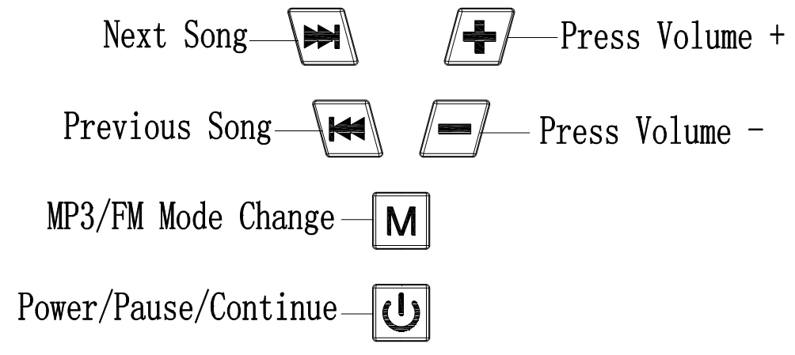
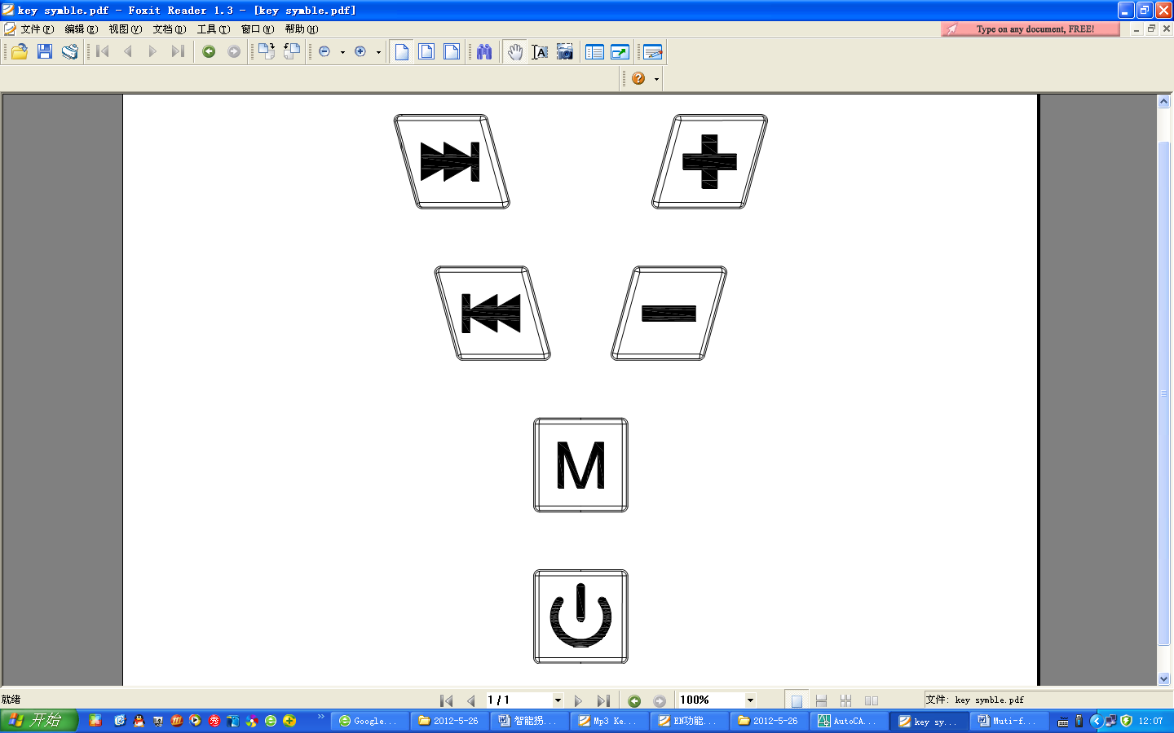
2.1 Insert the TF card or the U disk, unit will playing automatic
2.2 “ ” MP3 the next song
2.3 “ ” MP3 the previous song
2.4 “ ” Volume up +
2.5 “ ” Volume down -
2.6 “ ” MP3/FM radio mode change
2.7 “ ” Power ON/OFF/MP3 Pause/MP3 continue

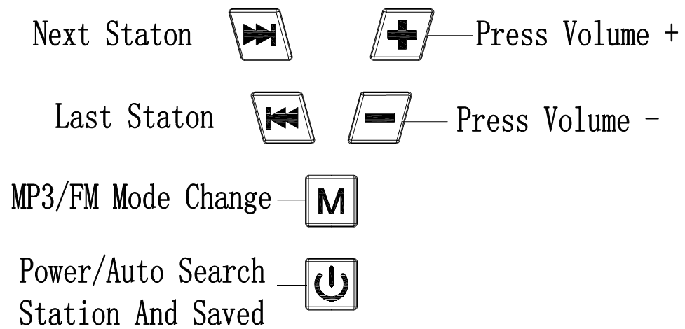
3．FM radio operating：Pressing on the power key 3S to open / shut off
3.1 Short press “ ”Key，change to FM mode
3.2 “ ” listen to the next radio station
3.3 “ ” listen to the previous radio station
3.4 “ ” long press Volume up +
3.5 “ ” Long press Volume down -
3.6 “ ” MP3/FM radio mode change
3.7 “ ” Power ON/OFF/automatic search radio stations and saved

Functions introduce
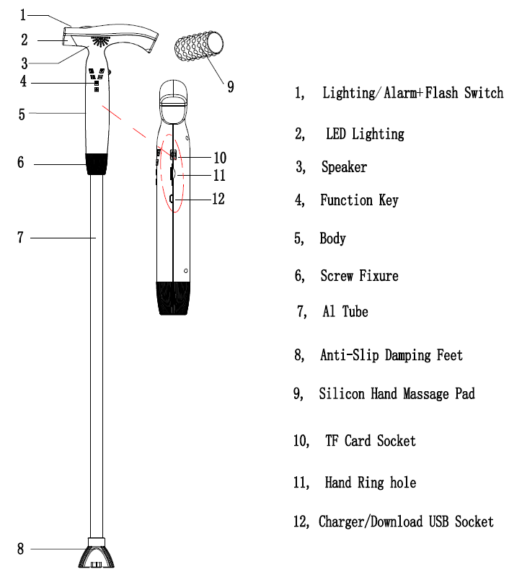

Charge operation：
Connecting the USB cable with adaptor, the adapter use the mobile charger that output DC 5.0V, charging time: 3-8 hours,
Connecting the USB cable with Computer, can download the songs to TF card

Note
1. When not in use, please shut off the power,
2. Please recharge the battery after long time not to use
3. When the Volume is smaller or the lighting darken, means that the battery is at low Voltage, please recharge in time
4. The charge Voltage should at 5.0V DC，
5. The Hi-Capacity polymer lithium battery, rating 3.7V, 1000MAH

